

**making the MFDs think™**

**YSoft SafeQ 5 - Release notes**

February 05, 2015

**TABLE OF CONTENTS**

1 More high-level details about YSoft SafeQ 5 features follow: 4

2 Maintenance Update 13 (05/02/2015) 6

3 Embedded Terminals (MFD Panel Integrated) 8

3.1 Known limitations 13

**DOCUMENT DESCRIPTION**

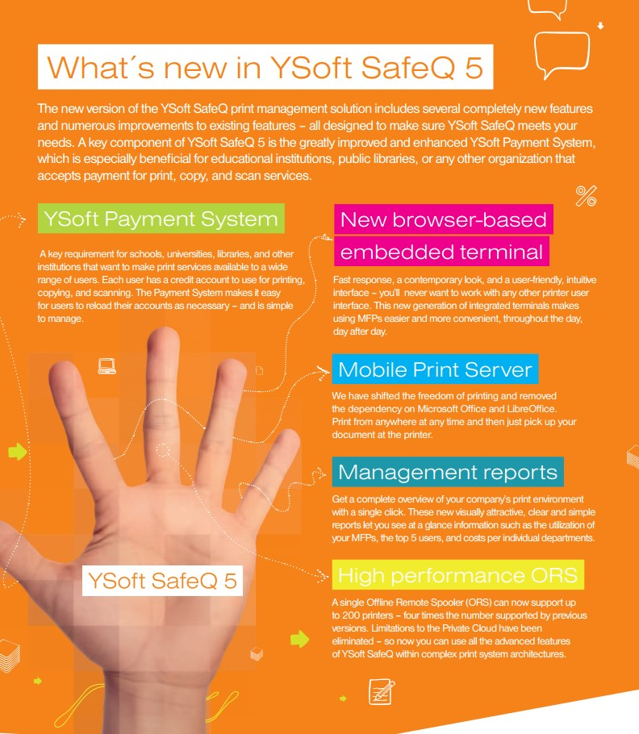

# MORE HIGH-LEVEL DETAILS ABOUT YSOFT SAFEQ 5 FEATURES FOLLOW:

 **YSoft Payment System** - Allow users to pay for print, copy or scan services in your environment. Users are charged based on prices defined in YSoft SafeQ, using pre-charged money on their accounts. Users are able to recharge their account using YSoft Payment Machine (recharging station) and manually-operated Cash Desk. Integration with third-party systems is possible thanks to robust set of APIs. Support for PayPal and Dibs included in the form of standalone plugins.

 **Mobile Print Server** - Allow your end users to print from devices on the go. No need to teach your users anything complex or install drivers; the solution is as simple as sending an e-mail or uploading a document via designated web page. No need to install third-party software like Microsoft Office or Libre Office to perform document conversion.

**YSoft SafeQ Embedded Terminal** - New browser-based terminal with updated graphical and interaction design lowers the amount of time your users need to spend with multifunction devices.

 **Management Reports** - Obtain visually beautiful and structured report with one click. Report provides a complete picture of the print environment, including information about paper consumption, printer utilization, prints per user for specified period.

 **Private Cloud Technology** - Large deployments are generally supported using distributed architecture model (central management and local spoolers). YSoft SafeQ 5 brings an improved **High-Performance Offline Remote Spoolers**, which are able to handle up to 200 connected devices. With server-level Print roaming, users can pick up their jobs in the entire print environment.

 **Rule-based engine** - Apply rules over print jobs. Force monochrome instead of color, double-sided instead of single-side print. Apply more rules based on different events and options. Simple wizard is available even for unexperienced administrators.

**Collaboration** - Multiple users working on a same project, admin picking up jobs for the manager. Shared queues and Delegation print features allows sharing print jobs among working groups or delegate the print release to another team members.

**Assignable price lists** - Create one price list or custom price list for every user, device or cost center.

Make sure that each person, cost center or device is billed according to your internal guidelines and policies.

 **Multi-level Billing Codes** - Monitor costs for different customers, projects or even departments using multi-level billing codes (also known as project codes). Users can change the billing code using external or embedded terminal, or at the workstation.

 **Reporting** - Automatic or manual reports available in web administration, including Green reports and **Central Reporting Services** support. Check spent and saved money and allow your users to see their statistics.

 **Administration and User web interface** - Easy-to-use web interface, which includesAdmin Dashboardand User Dashboard*.* Admin dashboard provides tools for managing users, devices, print queues, scan workflows and other parts of the system.

 **Integrated installation** - Basic server installation and deployment wizard. Advanced or large deployments can be satisfied with set of standalone packages for different parts of YSoft SafeQ.

 **Licensing System** - The all new per-device, flexible licensing model. Product can be quickly activated online or offline using new, user-friendly steps. New license information is automatically distributed within the entire system.

# MAINTENANCE UPDATE 13 (05/02/2015)

**What's new**

An informative message about restricted permissions is displayed in case a user with access restrictions for printing navigates to the Print tab on the browser based YSoft SafeQ Embedded Terminals.

**Fixes**

YSoft SafeQ Embedded Terminal for Konica Minolta: Fixed issue that prevented the job list to be correctly displayed in case hundreds of print jobs are waiting in the print queue.

YSoft SafeQ Embedded Terminal for Ricoh: Fixed issue when the card swipe was ignored in other application than YSoft SafeQ.

YSoft SafeQ Embedded Terminal for Toshiba: Details about authentication process were added to the log files.

YSoft SafeQ Embedded Terminal for Xerox: Fixed issue that prevented the embedded terminal to be installed in case the devices address was specified as fully qualified domain name.

**Early Access Program**

New YSoft SafeQ Embedded Terminal for Fuji Xerox has been introduced. The new terminal allows to use additional authentication options (PIN and Card, PIN or Card etc.), supports USB card readers and improves the behavior in connection with Payment System. The new terminal requires support of eXtensible Customizing Platform. M ore information about the terminal can be found in the following article.

YSoft SafeQ Embedded Terminal for Samsung: Fixed issue when log out by a card swipe occasionally lead to unexpected behavior.

**Warning**

Upgrade from Service Release 8 and lower requires re-installation of the YSoft SafeQ Embedded Terminals for Konica Minolta. In case the terminals are not re-installed, the users might not be able to authenticate.



When updating to a new Service Release, all installed components (YSoft SafeQ CML/ORS/CRS servers, Mobile Print Server, YSoft Payment System and YSoft Payment System plugins) have to be updated.



Because of the change in classes used for logging, update of the CRS server to SR4 or higher will overwrite the log4j.xml file.



Upgrade from YSoft SafeQ 4 using the bundle installer is not supported.

**Currently known limitations are listed below.** Some of these can be and are planned to be addressed with a comprehensive fix, other may depend on the available technology from a particular vendor:

When installing a new installation of YSoft SafeQ on a 32-bit operating system, the web server roles needs be enabled manually. For more information please contact the Customer Support Services.

Due to change in name of DIBS and PayPal plugin, it is not possible to update from version 1.0.6 or older to version 1.0.7 or later. The plugins has to be uninstalled manually before the newest version of plugins is installed.

Printers with EFI controller are not supported.

Accounting on Production Printers is not supported.

Xerox JBA (onbox/offbox) authentication is not supported.

Terminal reinstallation history (on device setting/terminal) is not supported

Displaying the statistics of printed pages on the embedded terminals is not supported.

Hardware terminals: When you try to copy/scan for more money than allowed by balance, paper jam might occur (e.g. when money is available only for part of jobs but not all, printing is stopped when money is depleted).

Xerox smart cards support (via USB smart card reader, via Terminal Professional as a smart cards reader) is missing.

Terminal Server: when uninstalling device from CML and moving it to ORS, device is not unregistered from CML terminal server. It can cause that accounting information can be used by CML (instead of

ORS)

Not all jobs may be printed, when jobs are sent to different node in a cluster than the embedded terminal is installed.

Konica Minolta Zeus MFPs with browser terminal may not allow printing any jobs when a user is in a group with forbidden color print.

# EMBEDDED TERMINALS (MFD PANEL INTEGRATED)



List of compatible devices is always available in

.

[Hardware Compatibility List (HCL](https://portal.ysoft.com/YSoftPartnerPortal/media/hcl/export/hcl.html)

[)](https://portal.ysoft.com/YSoftPartnerPortal/media/hcl/export/hcl.html)

**Vendor**

**Comments**

**Authentication**



with XCP

Direct printing works, but the

print jobs are performed even

when the user has insufficient

credit.

Print All works, but if the user

is out of credit, the printing

continues and a debt record is

created.

When swiping a card at the

card reader when the device

is in a sleep mode, the user is

not authenticated.

Scan feature can not be

blocked on some firmwares of

devices.

YSoft SafeQ Embedded

Terminal for Fuji Xerox with

XCP is available only under

.

Early Access Program

All authentication options (

).

Terminal Authentication Matrix

Card authentication with optional

USB card reader.

Embedded Terminal is software extension of the Fuji Xerox devices. Embedded Terminal requires licensed and configured Fuji Xerox ApeOS Connection IV at the device. User interface walkthrough is available at Using YSoft SafeQ Embedded Terminal for Fuji Xerox Apeos. Direct printing in combination with Authentication module works, however (any) user must authenticate in order for the jobs to be released by the printer (technology limitation).



Username & password, PIN.

Card authentication with optional EPA card reader.

Card self-registration possible using Card Activation Code.



Embedded Terminal is

software extension of Konica

Minolta devices.

Embedded Terminal requires

licensed and configured

Konica Minolta OpenAPI

platform at the device (

OpenAPI version 3.6 or higher

).

Konica Minolta OpenAPI3

Account Map is recommended

option for accounting.

Konica Minolta MyPanel

application or web-browser

support requires OpenAPI

version 3.6 or higher and an

iOption license.

Most of the printers require

extended memory and hard

drive for full functionality (

more details in Hardware

Compatibility List).

User interface walkthrough is

available at

Using YSoft

SafeQ Embedded Terminal for

.

Konica Minolta (OpenAPI)

All authentication options (

).

Terminal Authentication Matrix

Card authentication with optional

USB card reader.



Terminal is software extension

to the OKI MFD interface.

Terminal requires properly

licensed and configured Open

Platform.

see

for compatible

[I](https://portal.ysoft.com/YSoftPartnerPortal/media/hcl/export/hcl.html)

[HCL - OK](https://portal.ysoft.com/YSoftPartnerPortal/media/hcl/export/hcl.html)

devices.

YSoft Payment System



features are not supported.

Access restrictions are not



supported.

YSoft SafeQ Embedded

Terminal for OKI is available

only under

Early Access

.

Program

Username & password.

Card authentication with optional

USB card reader.



Embedded Terminal is

software extension of Ricoh

devices.

Terminal requires licensed

and configured Ricoh ESA™

Platform at the MFD (SDK/J

version 4+).

Java Card (is already

delivered with newer types of

Ricoh devices).

User interface walkthrough is

available at

Using YSoft

SafeQ Embedded Terminal for

.

Ricoh (ESA)

All authentication options (

).

Terminal Authentication Matrix

Card authentication with optional

USB card reader.



Embedded Terminal is

software extension of

Samsung devices.

Devices built on XOA-E

platform are supported only.

See

for

[HCL - Samsun](https://portal.ysoft.com/YSoftPartnerPortal/media/hcl/export/hcl.html)

[g](https://portal.ysoft.com/YSoftPartnerPortal/media/hcl/export/hcl.html)

compatible devices.

YSoft SafeQ Embedded

Terminal for Samsung

requires XOA framework

version 1.21 or higher.

YSoft SafeQ Embedded

Terminal for Samsung is

available only under

Early

.

Access Program

All authentication options (

).

Terminal Authentication Matrix

Card authentication with optional

USB card reader.



Embedded Terminal is

software extension of Sharp

devices.

Embedded Terminal requires

licensed and configured Sharp

OSA Platform (ACM and EAM

module) at the device (OSA

version 3.5 and higher).

Without EAM module,



is not

Scan management

available and a print job list is

not refreshed after print.

YSoft Payment System is

supported only on the devices

with AMX 3 license.

User interface walkthrough is

available at

Using YSoft

SafeQ Embedded Terminal for

.

Sharp (OSA)

All authentication options (

).

Terminal Authentication Matrix

Card authentication with optional

USB card reader or network card

reader (which requires its own IP

address).



Terminal is software extension

to the Toshiba MFD interface.

Terminal requires properly

licensed and configured

Toshiba Embedded Platform.

see

for

[HCL - Toshib](https://portal.ysoft.com/YSoftPartnerPortal/media/hcl/export/hcl.html)

[a](https://portal.ysoft.com/YSoftPartnerPortal/media/hcl/export/hcl.html)

compatible devices.

YSoft Payment System



features are not supported.

Access restrictions are not



supported.

Username & password.

Card authentication with optional

USB card reader.



Embedded Terminal is

software extension of Xerox

devices.

Embedded Terminal requires

licensed and configured Xerox

EIP Platform and Xerox XSA/

CA at the device (EIP version

1.5

and higher

).

YSoft Payment System is

supported only on the devices

with EIP version 2 and higher.

Xerox Network Accounting (

JBA) kit is recommended for

accounting.

User interface walkthrough is

available at

Using YSoft

SafeQ Embedded Terminal for

.

Xerox (EIP)

All authentication options (

)

Terminal Authentication Matrix

Card authentication with optional

network card reader (requires its

own IP address) or optional

generic USB card reader (

available at selected devices only -

see HCL for more details).

## KNOWN LIMITATIONS

Embedded Terminal cannot be uninstalled or reinstalled when users are logged in.

Xerox EIP, Fuji Xerox Apeos: It is not possible to restrict copying.

Xerox EIP: It is not possible to restrict user access rights (copy, color,...) per user, this option can be configured for each device by administrator manually.

Xerox EIP: If incorrect device credentials are used three times, device locks out access from the particular IP address for an hour. It is possible to erase the device lockout table manually.

Xerox EIP: Automatic log out does not work from the native copy menu.

Xerox EIP: Terminal inactivity timeout set in advanced tab of user's edit dialog (or in settings of Cost center, if this value is inherited from the Cost center) has to be different and ideally higher than the inactivity timeout set on device. If the timeout set per user is lower and a it expires, users will still be able to perform copies until the timeout set on device expires.

Xerox EIP: When actual Billing code is changed while a copy job is being performed, the copy job will be assigned the new Billing code.

Fuji Xerox Apeos: After automatic log out from SafeQ Application user is navigated to device main menu. After given time (based on device settings) user is also automatically logged out from device main menu.

Fuji Xerox Apeos: Only ASCII characters can be used when entering scanning workflow parameters on the embedded terminal.

Fuji Xerox Apeos: SSMI 1.4 or higher is required for the proper function of Payment System. In case the SSMI version is lower, the quota system is not applied and user can reach negative balance.

Fuji Xerox Apeos: Only card self-registration using card activation code is supported.

Fuji Xerox Apeos: When the card activation feature is enabled and there is card swipe with registered card, the user must always navigate through the Card Activation Code screen.

Fuji Xerox Apeos: Blank pages are accounted as BW print.

Fuji Xerox Apeos: It can take up to 15 minutes for device to return blocked money back to money account (if Payment System is used for print/copy/scan charging).

Fuji Xerox Apeos: Terminal inactivity timeout set in advanced tab of user's edit dialog (or in settings of Cost center, if this value is inherited from the Cost center) does not work. The session will be ended as soon as timeout set on device expires.

Fuji Xerox Apeos: When actual Billing code is changed while a copy job is being performed, the copy job will be assigned the new Billing code.

Konica Minolta: Jobs performed by Public user and jobs sent directly to printer are not accounted. Konica Minolta: Scan jobs performed by a user with insufficient credit are accounted. This may cause discrepancy between SafeQ reports and the information in Payment System

Konica Minolta OpenAPI 4.0: Name attribute of Scan workflow parameter has not to be longer than 16 characters and has to contain alphanumeric characters only.

Konica Minolta: native interface: Simplex/duplex option for scan is not propagated from scan workflow template, so following settings has to be set manually on device's panel. Konica Minolta: native interface: It is not possible to mark jobs as favorite.

Konica Minolta: Searchable PDF – searchable PDF (OCR) cannot be defaulted in Scanning Workflow - standard PDF is used instead.

Konica Minolta: With browser-based embedded terminal, Waiting folder is not refreshed after print.

The user must navigate to another folder in order to refresh the list.

Konica Minolta: With browser-based embedded terminal, scanning via WebDav is not supported. Konica Minolta: User with login name admin is not supported with YSoft SafeQ Embedded Terminal for Konica Minolta.

Konica Minolta: From Service Release 9 it is not possible to authenticate as an user via the web interface of the device.

Konica Minolta: For limitations related to printing from USB see the article printing from USB on YSoft SafeQ Embedded Terminal for Konica Minolta.

Konica Minolta C35: Logout before all jobs are printed causes that only the first job is accounted. Konica Minolta C35: Swipe with card immediately when authentication screen is displayed causes that user is not logged in.

Konica Minolta C284, C654: Card registration and billing code selection in the same authentication causes terminal to stay in main authentication screen.

Ricoh: When accounting is not licensed (Reporting or Credit and billing modules), only the print application is available on the terminal (users are unable to access the scanning application and the native copy application).

Ricoh: When disconnected USB card reader is connected again to the device (or device is woke up from sleep mode), it takes up to one minute (device dependent) till USB card reader responds again.

Ricoh C3002 has to be restarted for USB card reader to respond again.

Ricoh: Print from USB is not accounted and supported with Payment System.

Ricoh: Credit balance is not displayed on devices with small displays (e.g. MP301SPF).

Ricoh: Accounting for scanning via native scanning application is not supported.

Ricoh Aficio MP C300/C400 Series: Duplex scanning from ADF (automatic document feeder) works properly for MultipagePDF/TIFF, other output file types may have every other page rotated upside down.

Sharp: See article about licensing details.

Sharp: Failover is not supported.

Sharp: Print is not supported for users with username "admin", "blankuser", "service", "users", "other", "other2", "system", "invalid", "vendor", "vendor2" and "servicefss" as these are internally reserved words.

Toshiba: Embedded terminal accounting does not account blank pages.